Route for the March for Life 2020

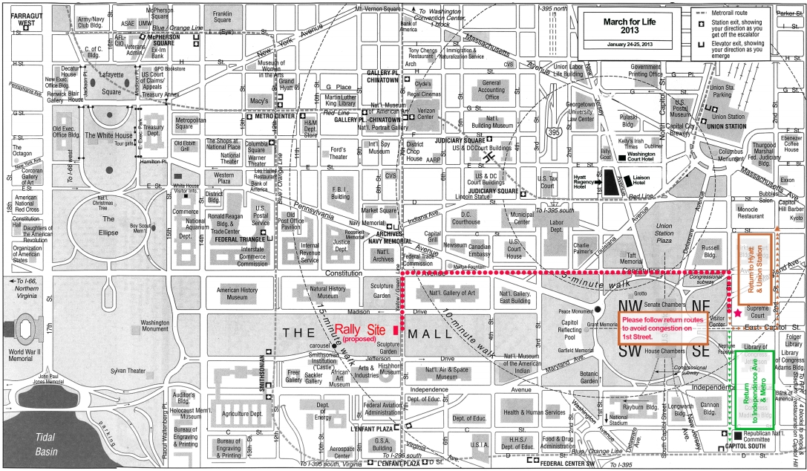
Meet here after March
St. Peter’s Church
313 2nd Street, SE
Washington Monument where buses will drop us off
325 Russell Building,
Kennedy Caucus Rm. For Senators Burr & Tillis NC Reception 1-5 pm
March for Life 2019

March for Life 2020 Itinerary
January 24, 2020

5:15-5:30 AM Arrival and Boarding of buses.
Breakfast will be distributed on the bus. Choices are egg-and-cheese burritos, cold cereal, or
breakfast bars with milk or coffee. If you prefer a different breakfast, please bring your own.
We will drive nonstop to DC.
5:40 AM Take roll
6:00 AM SHARP
Depart OLPH. If you’re not on the bus, you’ll have to catch up with us somewhere
on I-95.
10:30 AM Arrive at Basilica of the National Shrine of the Immaculate Conception, Washington,
DC
11:30 AM North Carolina Mass for Life in Upper Church. With Bishop Jugis and NC pro-lifers
~12:45 PM Depart Basilica for Washington Monument.
1:00-ish PM Join the March
2-5 PM Stop at Russell Senate Building. Those who wish to meet with Senators Tillis and Burr may do so at this time. Please remember that there is a security check. It is best to not bring anything in. There will be people from the team waiting outside who will watch your things. Check pockets for knives, metal things, etc.

4:00 PM Proceed to Supreme Court. Stop to listen to Silent No More speakers
4:30 PM Meet at St. Peter’s Church. Mandatory Roll Call
See map. There is light refreshment available for everyone while we wait for the buses to arrive.
5:00 PM Board Buses at Folger Park next to St. Peter’s 313 2nd Street SE
5:15 PM Depart DC
6:00 PM Arrive at Potomac Mills Mall.
Eat at Food Court. Exit 158B Prince William Parkway. Park by AMC Theatres
Restaurants include: McDonald’s; Pizza; Subs; Chinese; Japanese; Mediterranean and more
7:00 PM Depart for OLPH
11:00-ish PM Arrive at OLPH

